Algebra 1: Unit 14, Lesson 3

- Armani collected data about the types of ice cream cones and flavors of ice cream she sold at her shop on a hot summer day. The data is summarized in the table and segmented bar graph shown.
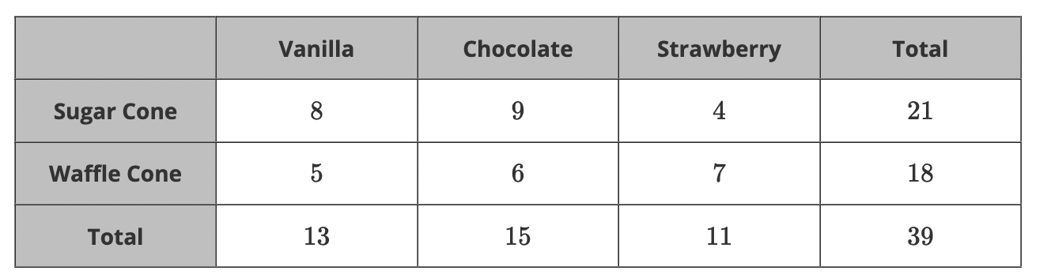

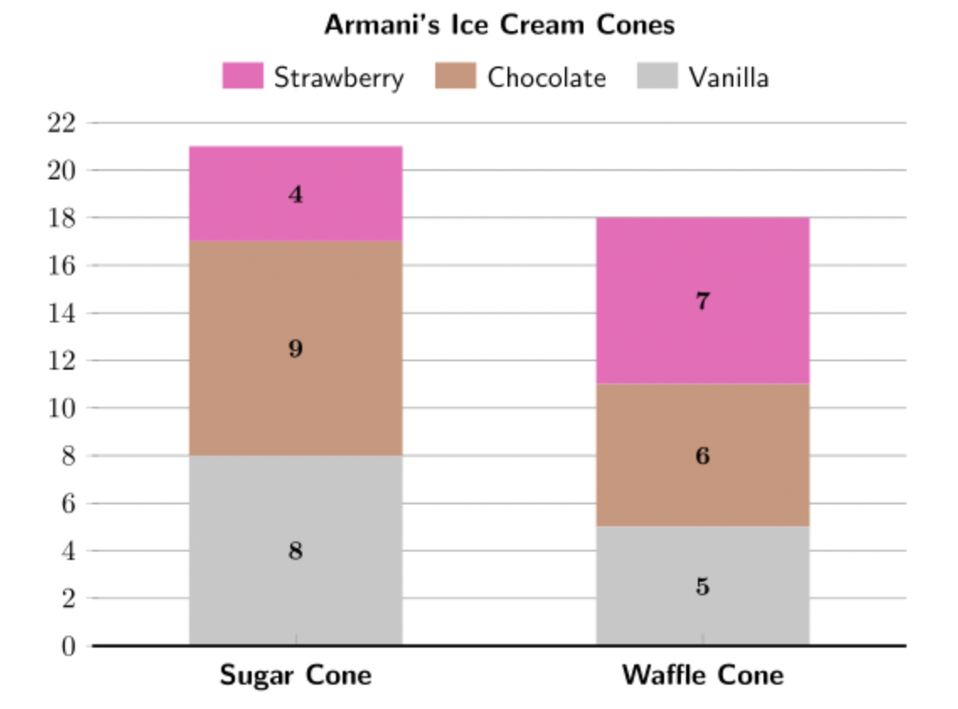

What is the marginal frequency for strawberry ice cream?
$$11$$

- Michelle has friends in $9$^{th} grade, $10$^{th} grade, and 11thgrade. She decided to make a survey about each friend's favorite animal. The summary of Michelle's findings are shown in the two-way table and the segmented bar graph.
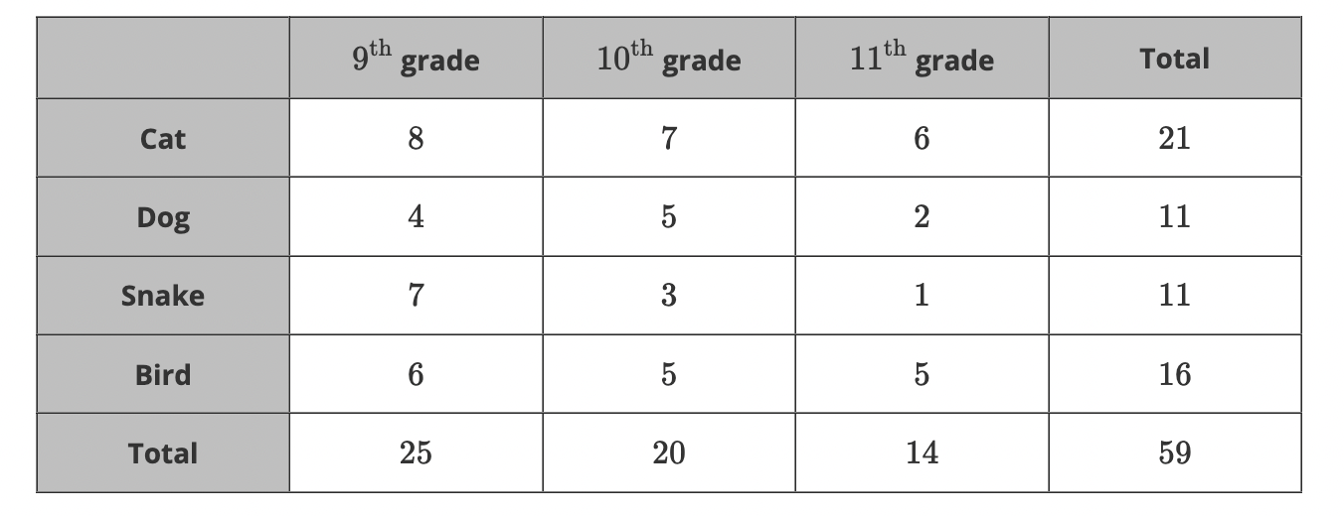

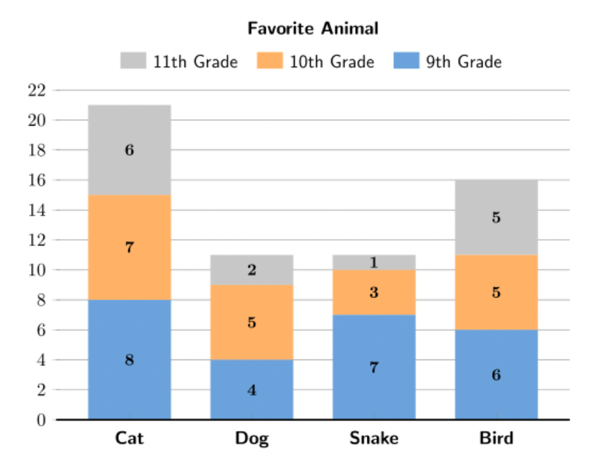
How many friends like birds?
$$16$$

- Gina tracked the packages delivered to her home over the past two months. The data collected is summarized in the table and segmented bar graph shown.
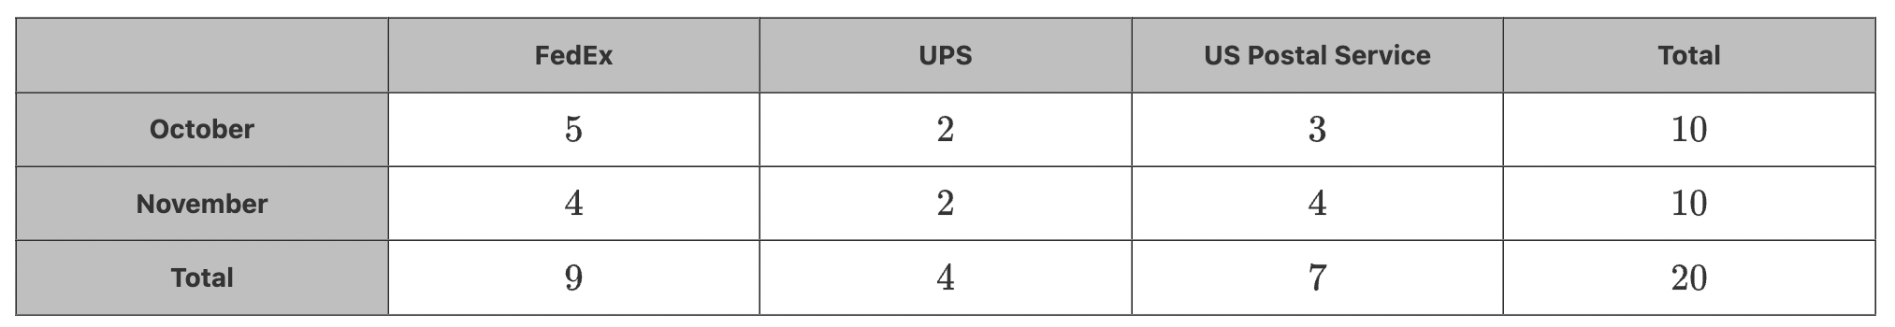
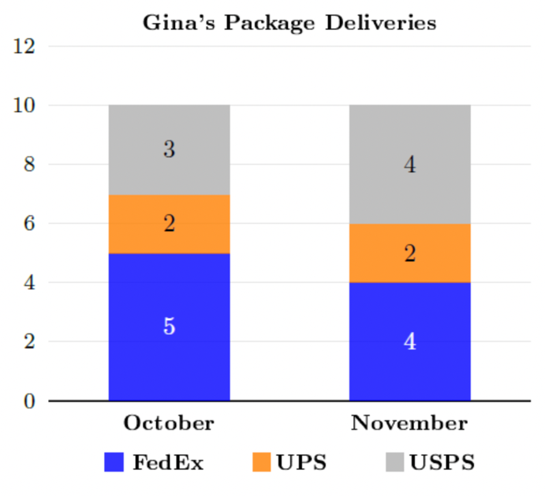
How can the marginal frequency be found for October?
Add the numbers in the blue box, orange box, and grey box in the October column of the segmented bar graph.

